Geometry Vocabulary

Lesson 11:

Acute Triangle
Definition:
If an angle measures more than 0° but less than 90°, the angle is acute.
Illustration:
ABC below is an acute angle.
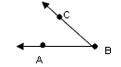
Examples:
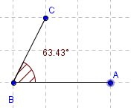

Congruent Angles

Definition: Congruent Angles have the same angle.

Illustration:
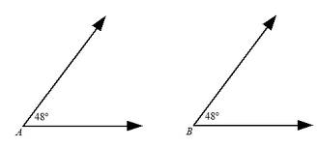

Examples:
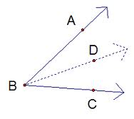

Acute Angle

Definition: An angle that is less than 90 degrees.

Illustration:
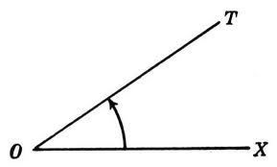

Examples:

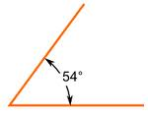

Right Angle
Definition: A right angle is exactly 90 degrees.

Illustration:
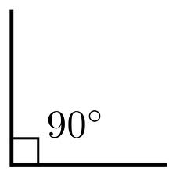

Examples:



Obtuse Angle
Definition: An angle larger than 90 degrees, but less than 180.

Illustration:
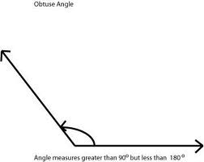

Examples:

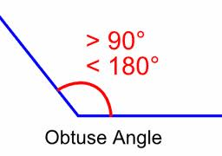

Straight Angle
Definition: A straight angle is 180 degrees.

Illustration:
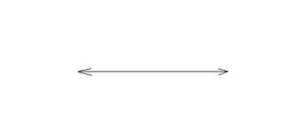
Examples:
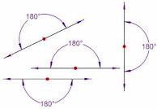

Reflex Angle
Definition: A reflex angle is more than 180 degrees but less than 360 degrees.

Illustration:

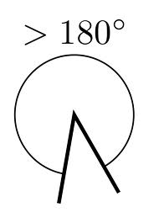
Examples:
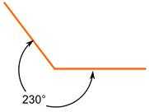

Adjacent Angles
Definition: Two angles are Adjacent if they have a common side and a common vertex.

Illustration:
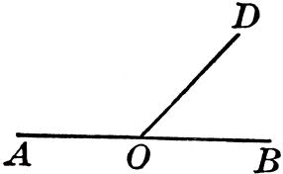

Examples:
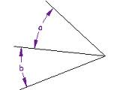

Supplementary Angles
Definition: Two angles are supplementary if they add up to 180 degrees.

Illustration:
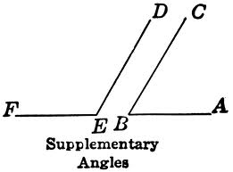

Examples:

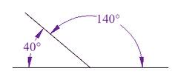

Complementary Angles
Definition: Two angles are complementary if they add up to 90 degrees.

Illustration:
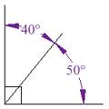

Examples:
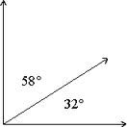

Vertical Angles
Definition: Vertical Angles are the angles opposite each other when two lines cross.

Illustration:
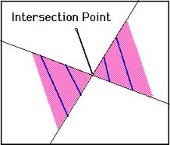
Examples:
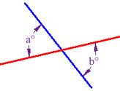

Angle Bisector
Definition: A line or ray that divides an angle in half.

Illustration:
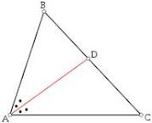

Examples:
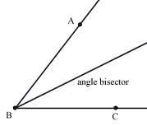

Linear Pair
Definition: Two angles that are adjacent and supplementary.

Illustration:
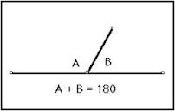

Examples: Angles 3 and 4 are a linear pair.
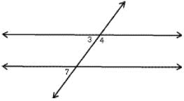

Protractor
Definition: An instrument for measuring angles.

Illustration:
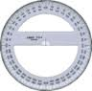

Examples:
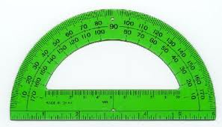

Angle Addition Postulate
Definition: States that if a point S lies in the interior of <PQR, then
<PQS + <SQR = <PQR

Illustration:
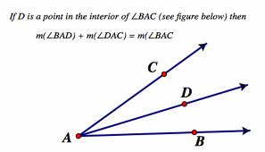

Examples: <BOC + <AOB = <PQR
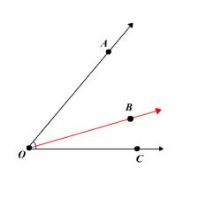

Perpendicular Lines
Definition: A line is perpendicular to another if they meet at 90 degrees.

Illustration:
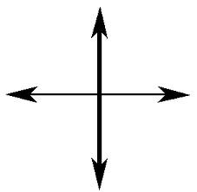

Examples:
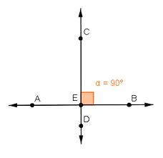

Parallel Lines
Definition: Lines are parallel if they are always the same distance apart.

Illustration:
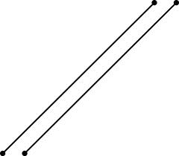
Examples:
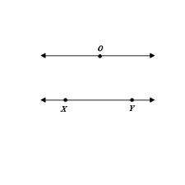

Transversal Lines
Definition: A line that cuts across two or more lines.

Illustration:
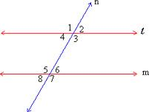
Examples:

Alternate Interior Angles
Definition: Pairs of angles on opposite sides of the transversal but inside the two lines.

Illustration:
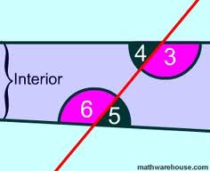

Examples: Angle 3 and 6 are alternate interior angles.
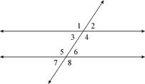

Alternate Exterior Angles
Definition: Pairs of angles on opposite sides of the transversal but outside the two lines.

Illustration:
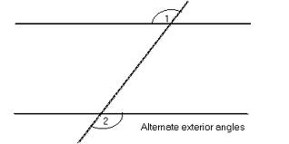
Examples:
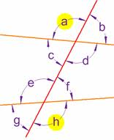

Corresponding Angles
Definition: Two congruent angles, both lying on the same side of the transversal and situated the same way on two different parallel lines.

Illustration:
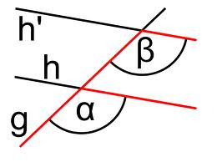
Examples: Angle C and B are corresponding angles.
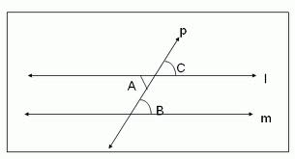

Consecutive Interior Angles
Definition: The pairs of angles on one side of the transversal but inside the two lines.

Illustration:
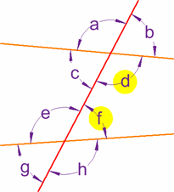
Examples:
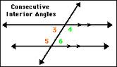

Same-Side Exterior Angles
Definition: Two angles outside the two parallel lines along the same side of a transversal line.

Illustration: Angle 1 and 7

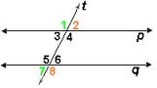

Examples: Angles E and F
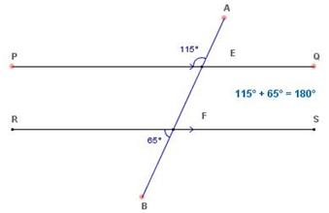
Week 12 Vocabulary

Acute Triangle
Definition: A triangle each of whose angles measures less than 90 degrees.

Illustration: 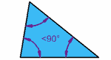

Examples: 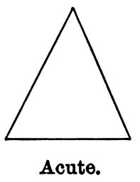

Right Triangle
Definition: A triangle that contains a right angle.

Illustration: 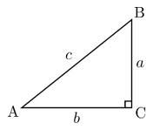

Examples: 

Obtuse Triangle
Definition: A triangle with an obtuse angle.

Illustration: 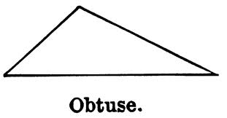

Examples: 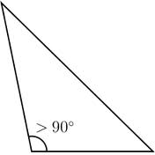

Equiangular Triangle
Definition: A triangle with equal angles.

Illustration: 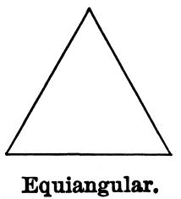

Examples: 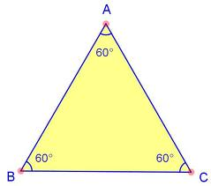

Scalene Triangle
Definition: A triangle with three unequal sides.

Illustration:

Examples:

Equilateral Triangle
Definition: A triangle that has three equal sides.

Illustration:

Examples:

Isosceles Triangle
Definition: A triangle with at least two equal sides.

Illustration:

Examples:

Triangle Sum Theorem
Definition: The sum of the interior angles of any triangle is equal to 180 degrees.

Illustration:

Examples:

Exterior Angle Theorem
Definition: An measure of an exterior angle of a triangle is equal to the sum of the measures of the two non-adjacent interior angles.
An exterior angle is formed by one side of a triangle and the extension of an adjacent side of the triangle.

Illustration: 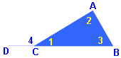

Examples:

Orthocenter
Definition:

Illustration:

Examples:

Centroid
Definition:

Illustration:

Examples:

Incenter
Definition:

Illustration:

Examples:

Circumcenter
Definition:

Illustration:

Examples:

Reflexive Property
Definition:

Illustration:

Examples:

SSS Postulate (Side-Side-Side)
Definition:

Illustration:

Examples:

SAS Postulate (Side-Angle-Side)
Definition:

Illustration:

Examples:

ASA Postulate (Angle-Side-Angle)
Definition:

Illustration:

Examples:

AAS Theorem (Angle-Angle-Side)
Definition:

Illustration:

Examples:

HL Theorem (Hypotenuse-Leg)
Definition:

Illustration:

Examples:

Corresponding-Parts-of-Congruent-Triangles (CPCTC)
Definition:

Illustration:

Examples:

Week 13

Ratio
Definition:

Illustration:

Examples:
Proportion
Definition:

Illustration:

Examples:
Congruent
Definition:

Illustration:

Examples:
Similar Triangles
Definition:

Illustration:

Examples:
Corresponding Angles
Definition:

Illustration:

Examples:
Cooresponding Sides
Definition:

Illustration:

Examples:
Angle-Angle Similarity Postulate
Definition:

Illustration:

Examples:
Side-Side-Side Similarity Postulate
Definition:

Illustration:

Examples:
Side-Angle-Side Similarity Postulate
Definition:

Illustration:

Examples:

Week 14
the Pythagorean theorem
Definition:

Illustration:

Examples:
Hypotenuse
Definition:

Illustration:

Examples:
Pythagorean Triples
Definition:

Illustration:

Examples:
the converse of the Pythagorean Theorem
Definition:

Illustration:

Examples:

Week 15
30°-60°-90° triangle
Definition:

Illustration:

Examples:
45°-45°-90° triangle
Definition:

Illustration:

Examples:
Hypotenuse
Opposite side of traingle
Definition:

Illustration:

Examples:
Adjacent side of a triangle
Definition:

Illustration:

Examples:
Sine
Definition:

Illustration:

Examples:
Cosine
Definition:

Illustration:

Examples:
Tangent
Definition:

Illustration:

Examples:
Angle of Depression
Definition:

Illustration:

Examples:
Inverse Sine
Definition:

Illustration:

Examples:
Inverse Cosine
Definition:

Illustration:

Examples:
Inverse Tangent
Definition:

Illustration:

Examples:

Week 16
Polygon
Definition:

Illustration:

Examples:
Regular Polygon
Definition:

Illustration:

Examples:
Irregular Polygon
Definition:

Illustration:

Examples:
Convex
Definition:

Illustration:

Examples:
Concave
Definition:

Illustration:

Examples:
Vertex
Definition:

Illustration:

Examples:
Interior Angle Sum Theorem
Definition:

Illustration:

Examples:
Exterior Angle Sum Theorem
Definition:

Illustration:

Examples:
Quadrilateral
Definition:

Illustration:

Examples:
Parallelogram
Definition:

Illustration:

Examples:
Rectangle
Definition:

Illustration:

Examples:
Rhombus
Definition:

Illustration:

Examples:
Square
Definition:

Illustration:

Examples:
Trapezoid
Definition:

Illustration:

Examples:
Kite
Definition:

Illustration:

Examples:
Consecutive Angles
Definition:

Illustration:

Examples:
Supplementary Angles
Definition:

Illustration:

Examples:
Diagonal
Definition:

Illustration:

Examples:
Median
Definition:

Illustration:

Examples:

Week 17

Circle
Definition:

Illustration:

Examples:
Semi-Circle
Definition:

Illustration:

Examples:
Radius
Definition:

Illustration:

Examples:
Diameter
Definition:

Illustration:

Examples:
Circumference
Definition:

Illustration:

Examples:
Chord
Definition:

Illustration:

Examples:
Secant
Definition:

Illustration:

Examples:
Tangent
Definition:

Illustration:

Examples:
Central Angle
Definition:

Illustration:

Examples:
Inscribed Angle
Definition:

Illustration:

Examples:
Arc Addition Postulate
Definition:

Illustration:

Examples:
Arc Lenght Formula
Definition:

Illustration:

Examples:
Sector of a Circle
Definition:

Illustration:

Examples:
Area of a Sector Formula
Definition:

Illustration:

Examples:

Week 18
Perimeter
Definition:

Illustration:

Examples:
Area
Definition:

Illustration:

Examples:
Surface Area
Definition:

Illustration:

Examples:
Volume
Definition:

Illustration:

Examples:
Geometric Net
Definition:

Illustration:

Examples:
Prism
Definition:

Illustration:

Examples:
Cylinder
Definition:

Illustration:

Examples:
Circle
Definition:

Illustration:

Examples:
Circumference
Definition:

Illustration:

Examples:
Radius
Definition:

Illustration:

Examples:
Diameter
Definition:

Illustration:

Examples:
Pyramid
Definition:

Illustration:

Examples:
Cone
Definition:

Illustration:

Examples:
Slant Height
Definition:

Illustration:

Examples:
Sphere
Definition:

Illustration:

Examples:

Week 18 Pt. 2
Consistent
Definition:

Illustration:

Examples:
Inconsistent
Definition:

Illustration:

Examples:
System of Equaitons
Definition:

Illustration:

Examples:
System of Inequalities
Definition:

Illustration:

Examples:
Inequality with a solid line
Definition:

Illustration:

Examples:
Inequality with a broken(dashed) line
Definition:

Illustration:

Examples:

Lesson 13:

Definition:

Illustration:

Examples:

Lesson 14:

Definition:

Illustration:

Examples:

Lesson 15:

Definition:

Illustration:

Examples:

Lesson 16:

Definition:

Illustration:

Examples:

Lesson 17:

Definition:

Illustration:

Examples:

Lesson 18:

Definition:

Illustration:

Examples:

